TechServe Mobile Users Guide

Contents
Windows Laptop / Desktop 2
Apple Mobile / Tablet 4
Android Mobile / Tablet 6
Initial Setup 7
Data Synchronization 9
Notifications 10
Working with Data 11
Frequently asked questions 13

Windows Laptop / Desktop
Click the TSM link provided to open the web page in your browser. It is highly recommended to use Chrome or Edge.
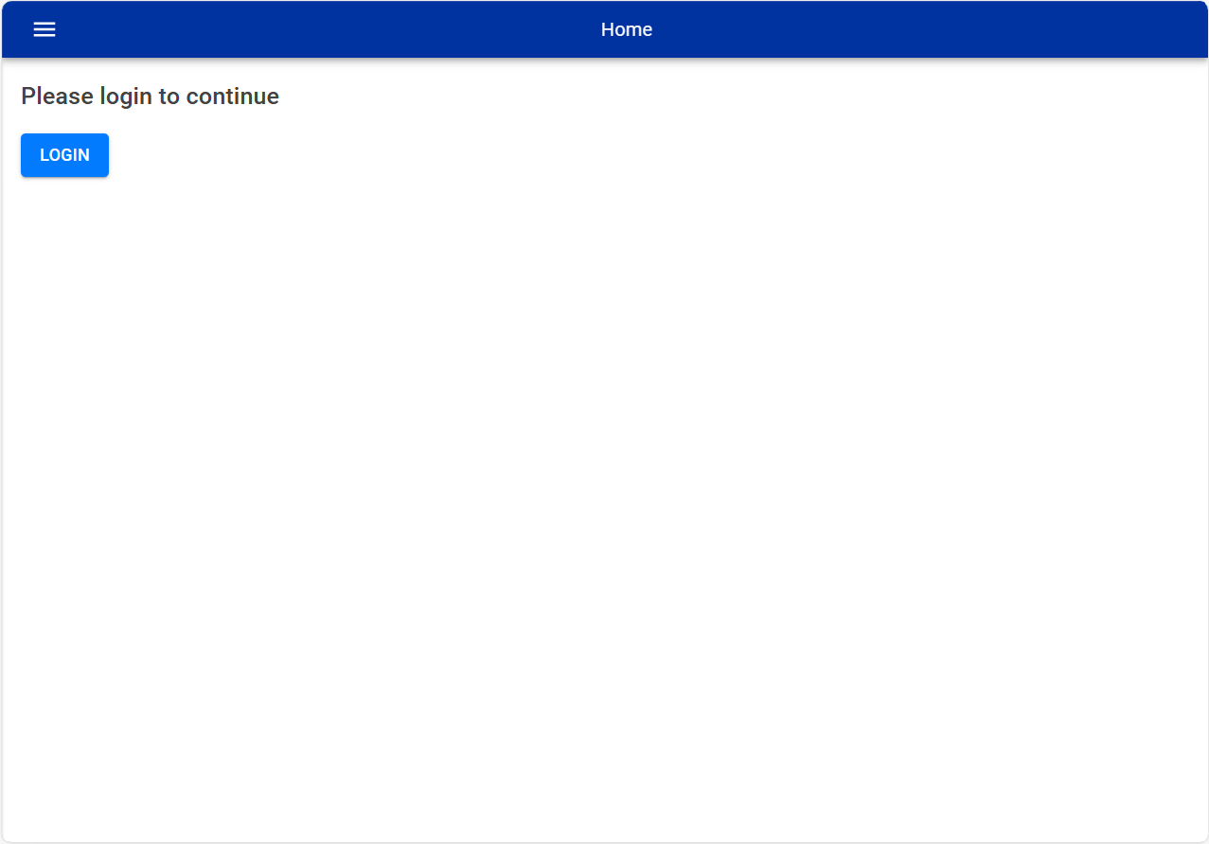
Before you click the Login button, install the application by clicking on the Install button on your browser, highlighted below:
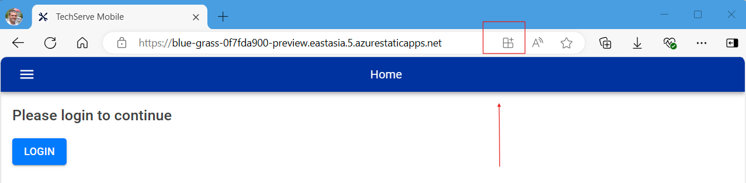

The following prompt will open to confirm the Installation. Click Install
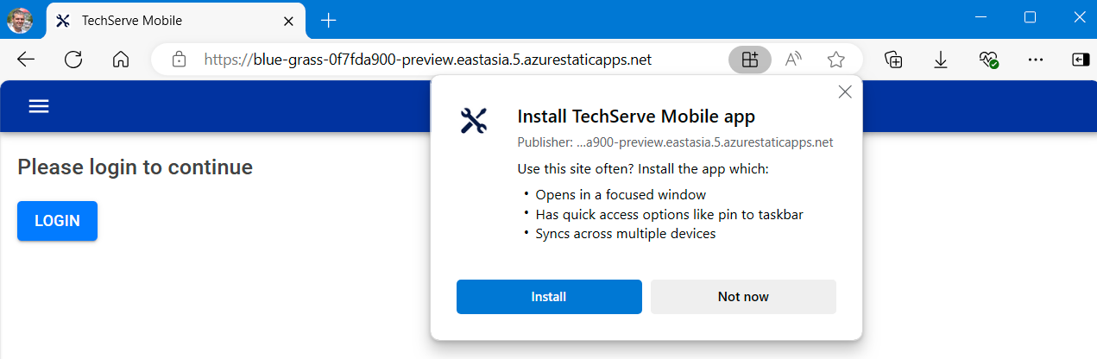

Once the installation is complete, tick all four options, and click Allow
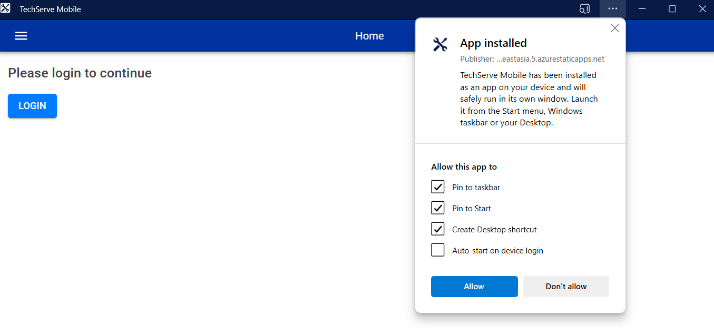
Please proceed to Initial Setup

Apple Mobile / Tablet
Click the TSM link provided to open the web page in your browser. It is recommended to use Chrome or Edge:
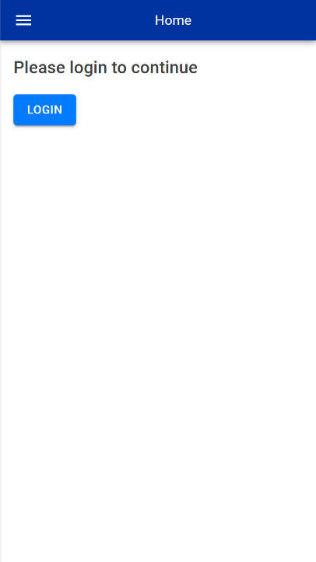
Before you click LOGIN, please install the application. On your device, click the Install button:
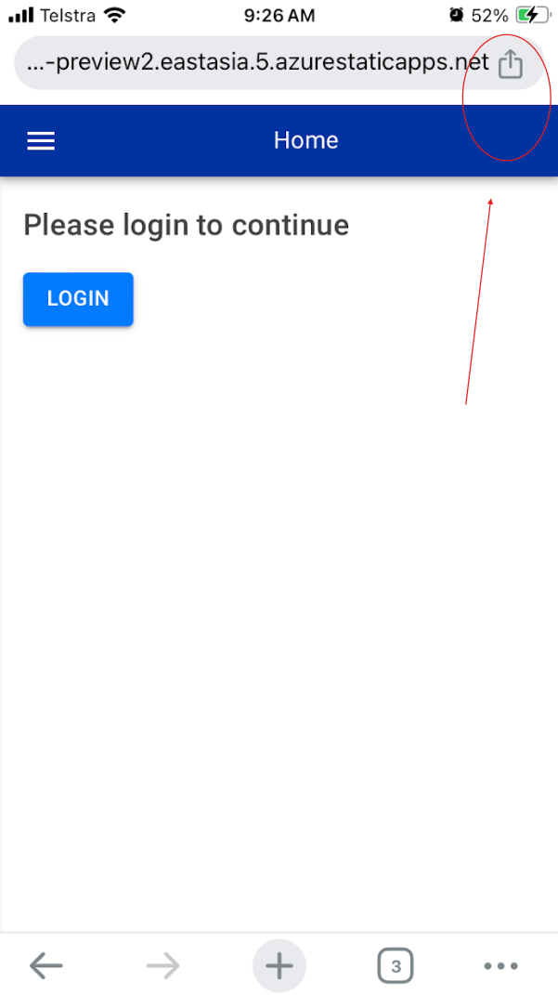
Then click on Add to Home Screen, and finally Add to complete the process:
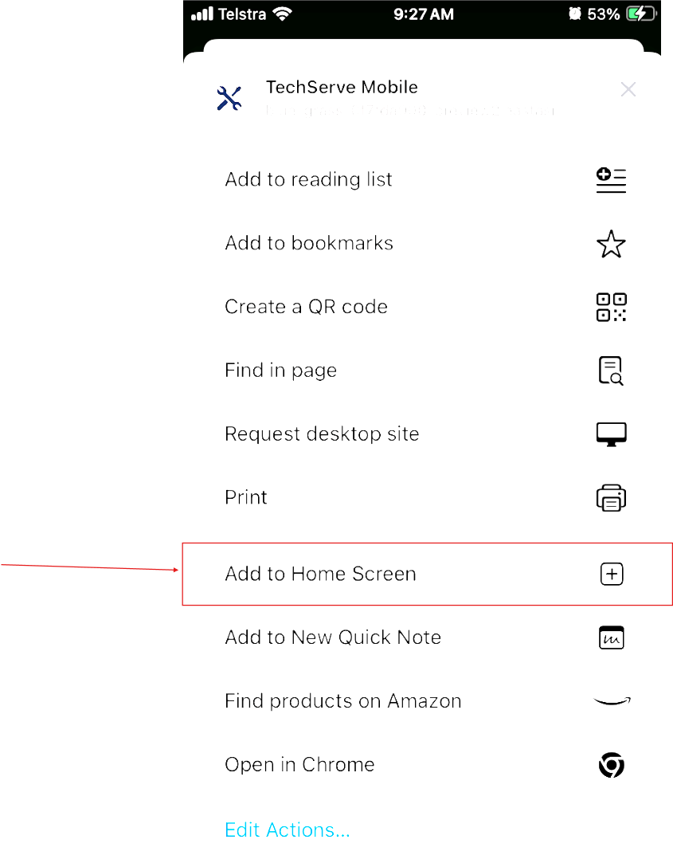
You should now have an icon on your device for TechServe.

Please proceed to Initial Setup

Android Mobile / Tablet
Click the TSM link provided to open the web page in your browser. It is recommended to use Chrome or Edge:
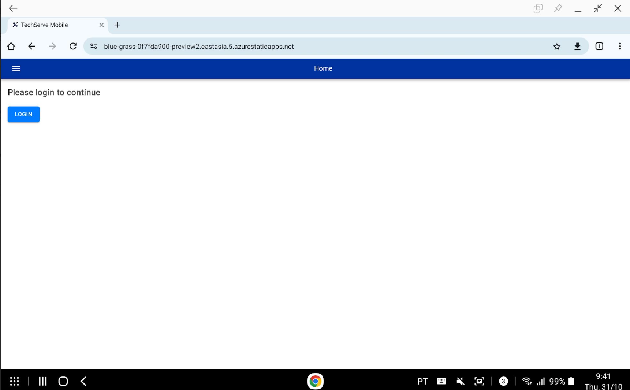
Before you click LOGIN, please install the application. On your device, click the Menu option, and then click Install App: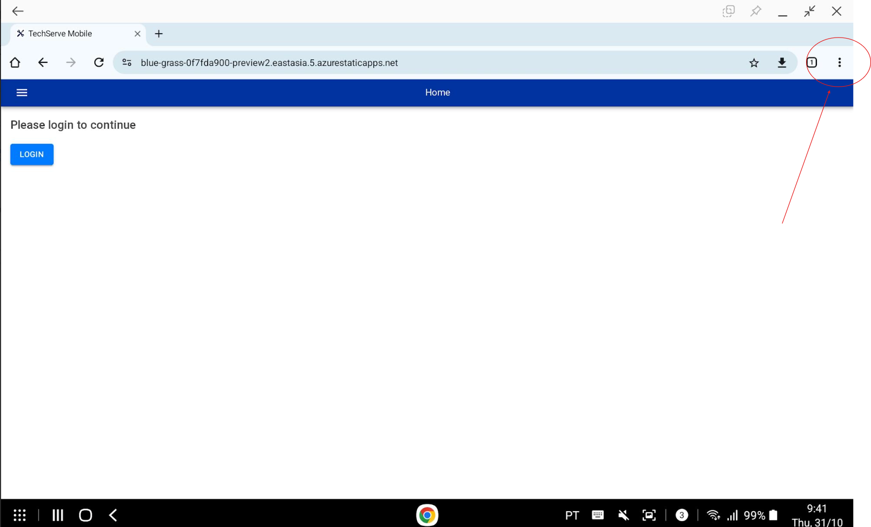
Please proceed to Initial Setup

Initial Setup
Click the Login button and enter your Windows username and password, using fmeone.com as the domain name. For example, if your username is joe.doe@freseniusmedicalcare.com, then enter joe.doe@fmeone.com

Once you have signed in, you should see the Home screen:
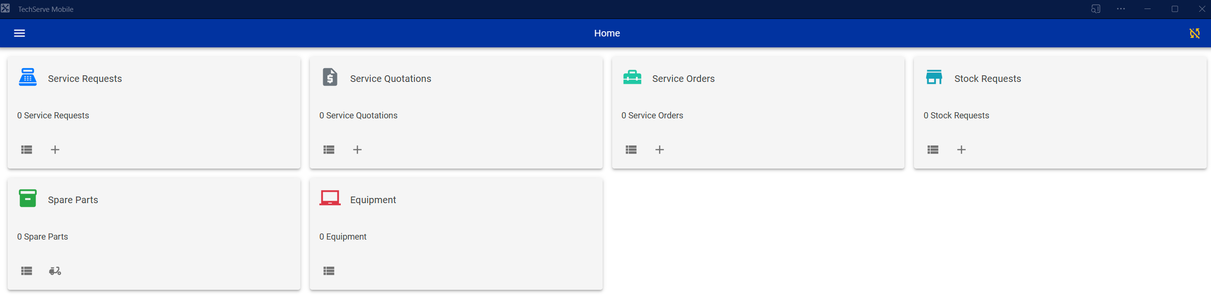

You can now enable Notifications and setup your Region. Open the Menu bar, and click on the Settings link:
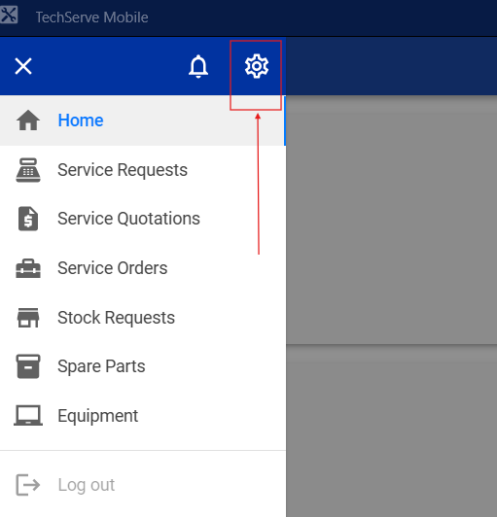
Under the Manage Notifications, click Subscribe.
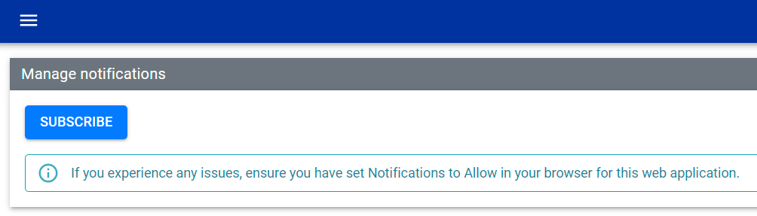
You will be prompted to Allow Notifications for this site. Click Allow.
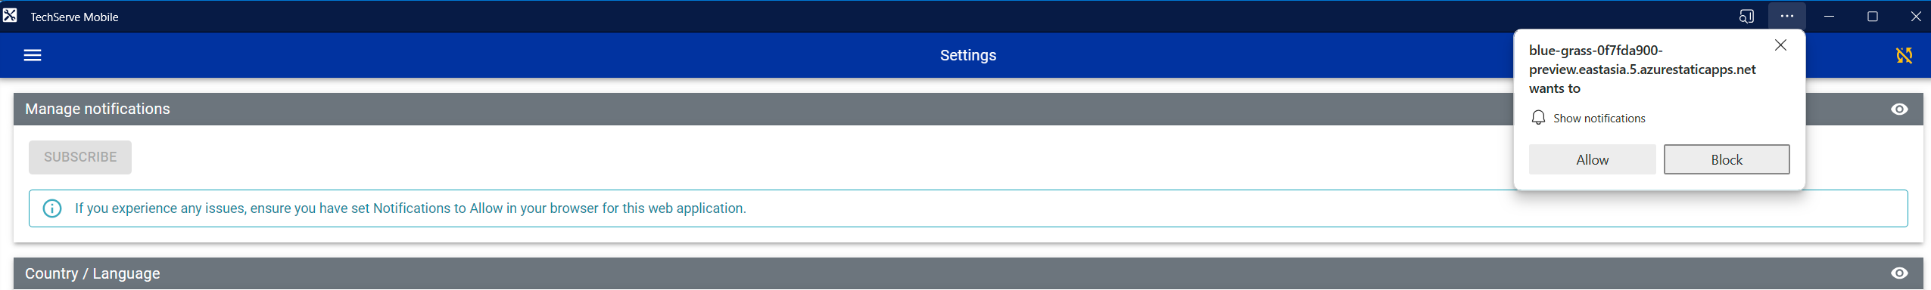
If the subscription was successful, click the Test button. You should receive a Notification shortly. If no notification is received after 2 minutes, ensure Do Not Disturb is not enabled and Notifications are enabled on your Windows and browser settings. If you experience issues receiving notifications, you can try a different internet browser on your device.

Select your Country / Language. The application will reload when the Country / Language is changed.

Setup is complete, and we can proceed to initial Data Synchronization. Click on the Data Sync icon as shown:
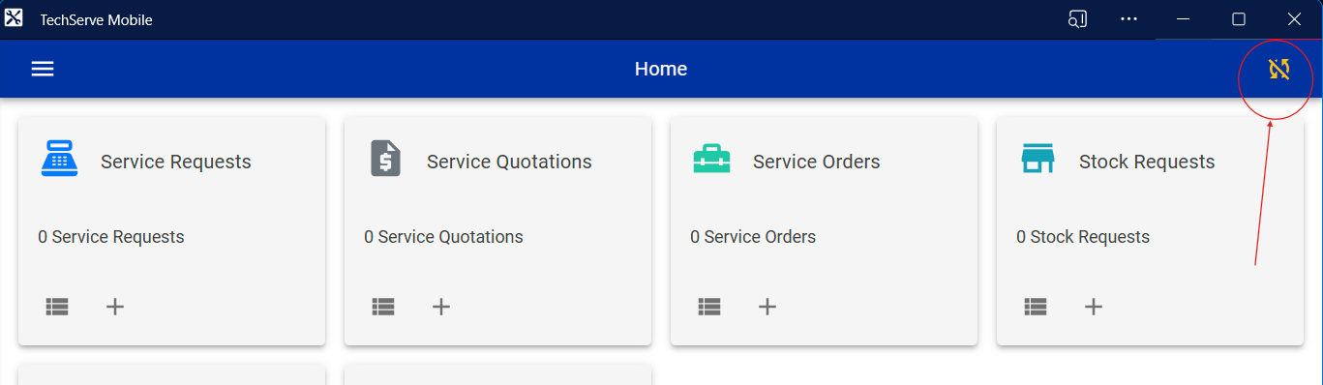
Please ensure you have a good network connection before performing an initial Data Sync! Click on the Sync All button to begin. This process will take a couple of minutes depending on your network connection / speed.
Once data has been synchronized, you can go back to the Home page, and the application is now ready for use.

If there are any updates, you will see an alert on the Home screen. To apply the update, click Reload Application:
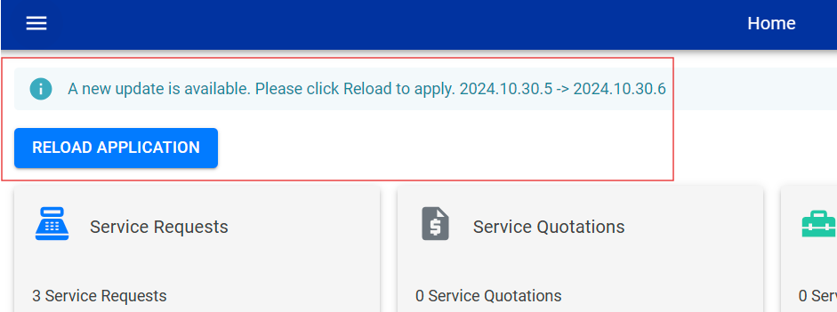

Data Synchronization
Data is automatically synchronized with the server every time you launch the application. This will check for any updates since the last synchronization. You can also manually synchronize data by clicking on the Data Sync link, and then click Sync All.
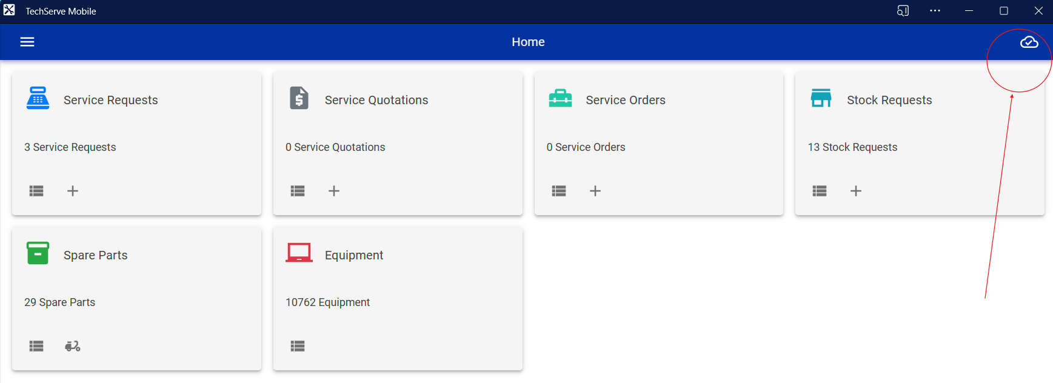
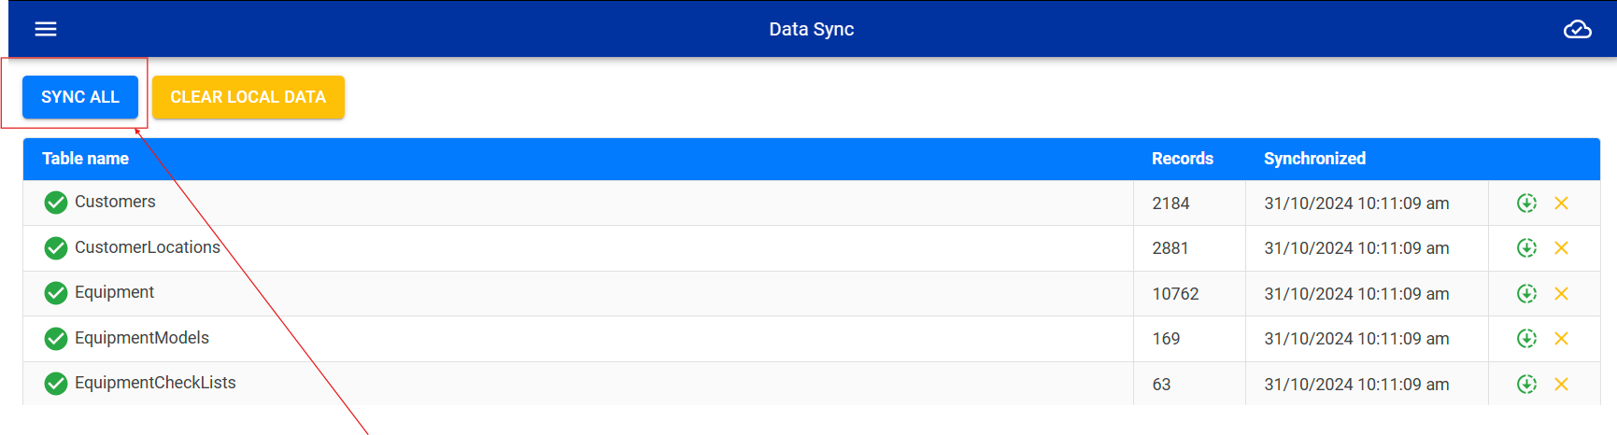
Alternatively, you can synchronize an individual table by clicking on the green link.
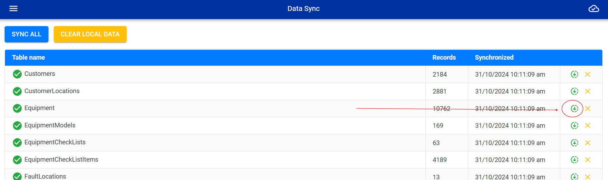
In the event of any issues using the application, you can clear the local data by clicking on Clear Local Data or the individual table clear link. Ensure any un-synchronized data has been sent to the server before performing this! This will only affect local data on your device and no server data will be affected.

Any data created will only be stored on your local device. It will not be saved to the server until it has been submitted / synchronized.

Notifications
You can view the latest notifications:
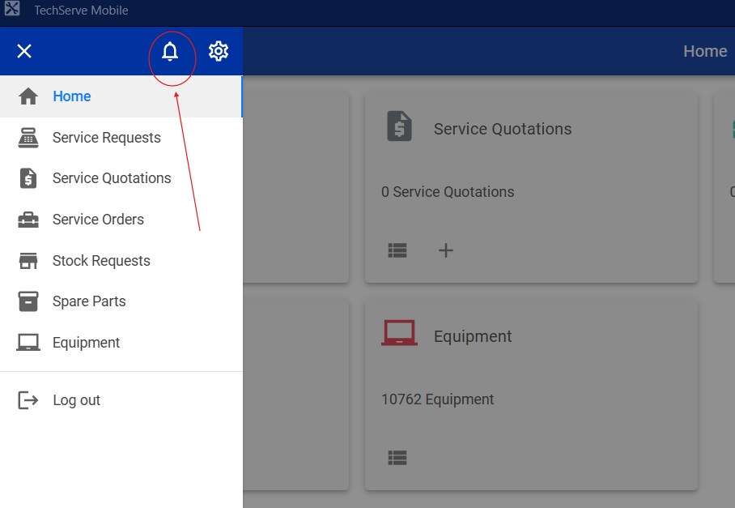
You can clear individual notifications once they have been actioned or are no longer relevant, or Clear All.
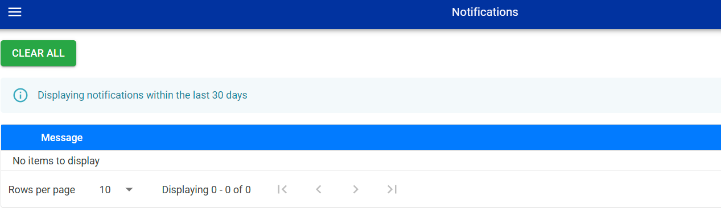

Working with Data
When working with data you can choose to work with local data “offline mode”, or server data “online mode”. Online mode requires internet connectivity.

By default, the application starts up in in offline mode. To change the data mode, click the connection link on any of the List screens: 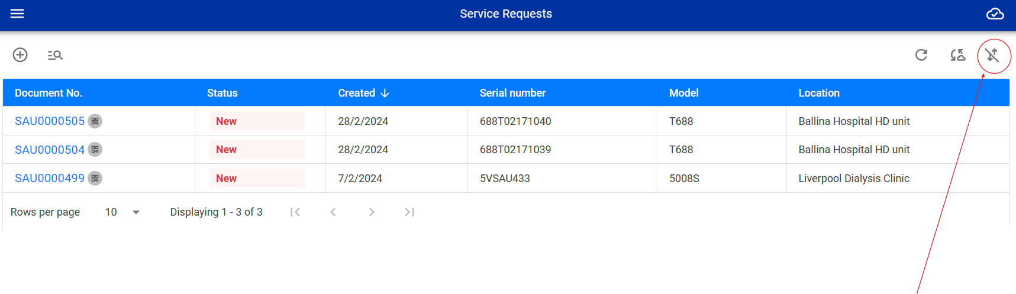
If the link is disabled, it indicates that a connection with the server is not available, or your login session has expired. Check your network connectivity and try again.
Once you are in online mode, the icon will change to green indicating that you are now connected to the server:
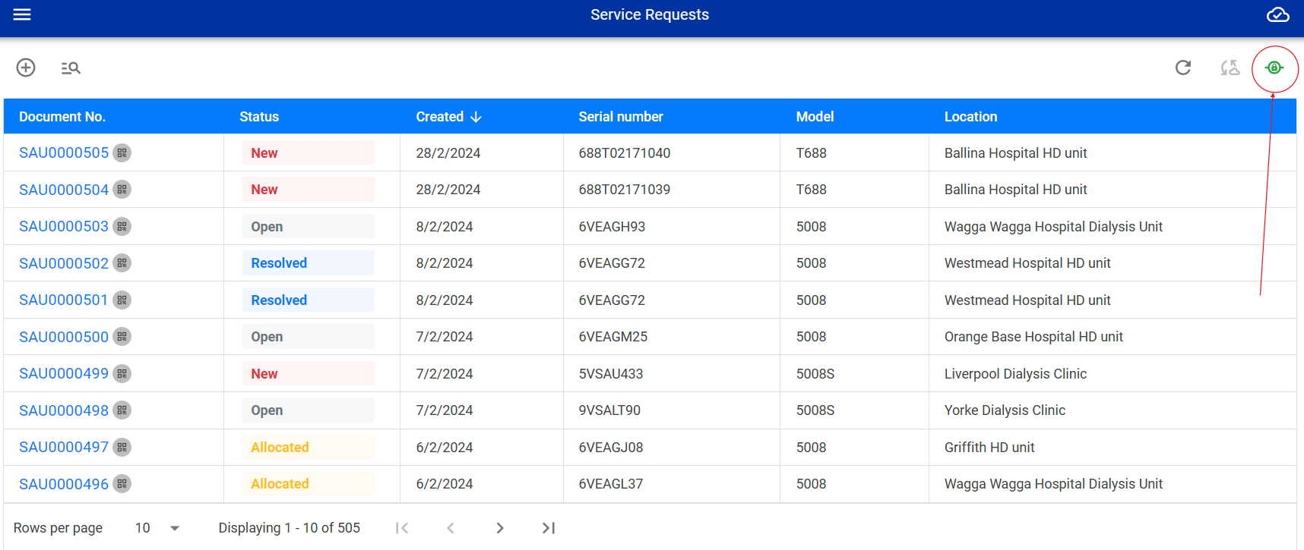
Clicking the green icon again will disconnect you from the server and revert to local data / offline mode.

In the List screens, you can also perform a manual synchronization to ensure you are working with the latest data available on the server. To synchronize, click the Sync link:
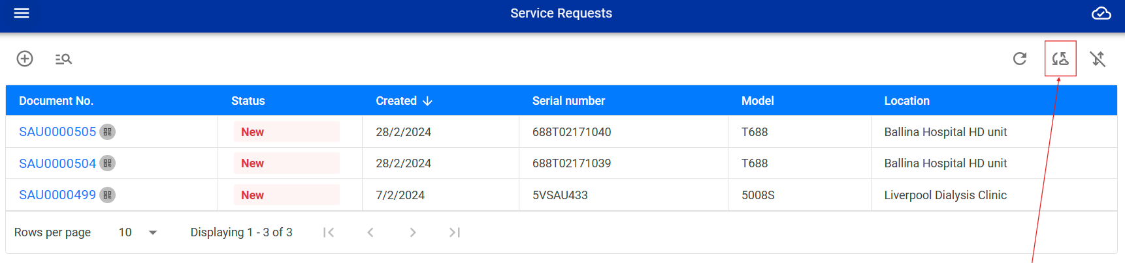
To refresh the data table, click the Refresh link:
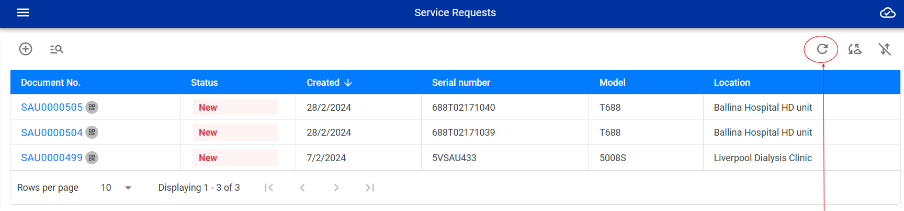
For most lists, you can add new records by clicking the Add link:
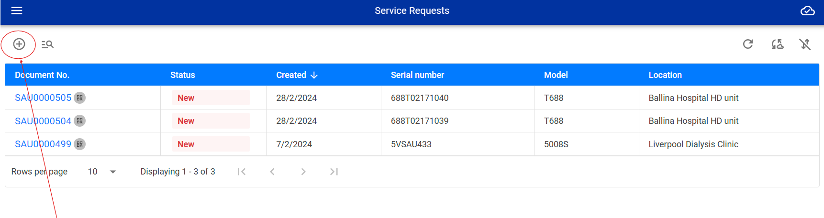
Please note that the Add new record link will add new data to your local data store, not the server. Only after you have submitted / synchronised the local data, will the information be available on the server.
Finally, you can perform some search functions by clicking the Filter link:
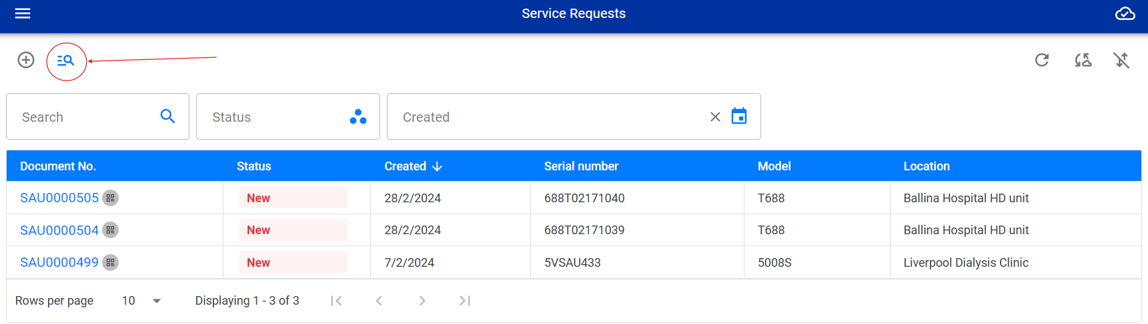
The filter functions are different depending on if you are in offline or online mode.

Frequently asked questions
- How do I Record Time
  - At this moment there is no Record Time function in TSM. You can still use the Record Time function in TechServe. Alternatively, please use the Service Request and Service Orders to record work performed. Record Time should only be used for recording time that is not related to a service.

- When I select Manufacturer Maintenance, I cannot select ESC.
  - This is by design. Manufacturer Maintenance includes an ESC therefore there is no need to select ESC

- I cannot see a spare part description when adding spare parts to a Quotation
  - If you are offline or your session has expired, it will not display the part description. Once you are online and your session is valid, it will automatically update the part description when you open the Quotation

- What is a Service Order / Where are Service Reports
  - A Service Report is now known as a Service Order. This is to align with the terminology used in SAP

- I cannot sign in
  - Please ensure you are using @fmeone.com account and not @fresniusmedicalcare.com
  - If you are still unable to log in, please reach out to your local IT for assistance

- I get an ERP Error when performing certain tasks
  - ERP Error is a direct response from SAP. You will need to work with your SAP data maintenance team to fix the issues as per the error message displayed. These cannot be fixed in TechServe

- Can I perform a Decommission service?
  - By selecting the Reason For Service 1W, you can then tick the Decommission check box and complete any checklists, if setup

- I cannot select 1E – First Installation Report as the Reason for Service
  - If a 1E has already been previously performed, you cannot select 1E again. Please select 1F – Reinstallation as the reason for service
- I am having an issue in TSM
  - Please log a JIRA ticket with as much information as possible or send an email to techserve.support@freseniusmedicalcare.com. While the ticket is been attended to, you can log into TechServe and continue working in there.

- I have TSM installed on my laptop and phone, but cannot see the data on both devices
  - Each installation of TSM is a separate database. If you create a service order on your laptop it will not be visible on your mobile device for example. It will only be visible across all devices once the service order has been submitted and synchronized with the server

- I can see equipment from other countries
  - Yes, TSM allows you to view equipment for other countries to allow more visibility when searching for information

- I cannot find a spare part when creating a service order
  - Only a small subset of spare parts will be shown. You can scroll down the list or use the search function to find your spare parts

